Effect of rice variety and amylose content on the texture and sensory acceptability of the main rice-based foods in Benin
M. Daouda^{1,2}, M. Oussou¹, J. Jasniewski² and Y. E. Madodé¹*
¹MSc. Muqsita DAOUDA, Laboratoire de Sciences et Technologies des Aliments (LaSTA), Université d’Abomey-Calavi (UAC), 03 BP 2819 Recette Jéricho, Cotonou 03, République du Bénin & LIBio/UL, F-54000 Nancy, France, E-mail : muqsitadaouda@gmail.com,
Tél. : +(229)0196449737, République du Bénin
MSc. Moréas OUSSOU, Laboratoire de Sciences et Technologies des Aliments (LaSTA), Université d’Abomey-Calavi (UAC), 03 BP 2819 Recette Jéricho, Cotonou 03, E-mail : moreassemevo@gmail.com, Tél. : +(229)0196891784, République du Bénin
Dr Ir (MC) Yann Eméric MADODE, Laboratoire de Sciences et Technologies des Aliments (LaSTA), Université d’Abomey-Calavi (UAC), 03 BP 2819 Recette Jéricho, Cotonou 03, E-mail : yann.madode@uac.bj, Tél. : +(229)0166695705, République du Bénin
²Dr (HDR) Jordane JASNIEWSKI, Laboratoire d’Ingénierie des Biomolécules (LIBio), Université de Lorraine (UL), F-54000 Nancy, E-mail : jordane.jasniewski@univ-lorraine.fr, Tél. : +33(0)372744092France
*Corresponding author: Dr Ir (MC) Yann Eméric MADODE E-mail: yann.madode@uac.bj
*DOI: https://doi.org/10.62344/6z9xqy50
Abstract
To properly evaluate the rice varieties that can be grown in Benin's agroecosystems, we need a better understanding of their physical and chemical properties, as well as how these properties influence the quality of the finished product. This study, therefore, aims to evaluate the effect of amylose content on the physicochemical properties and sensory acceptability of cooked rice and Ablo, with the goal of identifying the most suitable varieties for both uses. Seven rice varieties with different amylose content (low, intermediate, and high) were characterized. Sensory evaluations of Ablo and cooked rice from each variety were conducted in public places of Cotonou, Benin. The rice varieties IR 841 and Orilux 6 were the most appreciated for cooked rice due to their high grain aggregation, aroma whiteness, and low hardness and stickiness. Ablo prepared from the high-amylose varieties Adny-11 and Briz 8B was preferred due to its high whiteness, lightness, and intermediate hardness. While varieties with low to intermediate amylose content are generally considered more suitable for cooked rice, this study shows that high-quality Ablo can also be produced from certain high-amylose varieties, provided they possess favourable structural characteristics. These results indicate that Ablo quality is not determined solely by amylose content, but also by the specific physicochemical properties of the rice variety. The various physicochemical traits measured on Ablo allow for more efficient prediction of its sensory properties than those measured on cooked rice.
Keywords: Local rice, amylose content, Ablo, cooked rice, consumer acceptance, cooking quality
Effet de la variété de riz et de la teneur en amylose sur la texture et l’acceptabilité sensorielle des principaux produits dérivés du riz au Bénin
Résumé
Afin d’évaluer quelques variétés de riz cultivables dans les agroécosystèmes béninois, nous avons besoin de savoir comment les propriétés physiques et chimiques de ces variétés peuvent impacter la qualité finale des produits finis. L'étude a évalué l’effet de la teneur en amylose de sept variétés de riz (faible, intermédiaire et élevée) sur les propriétés physicochimiques et l’acceptabilité sensorielle du riz cuit et de Ablo au Bénin. Les analyses sensorielles réalisées à Cotonou ont montré que les variétés IR841 et Orilux 6 ont été les plus adaptées à l’obtention du riz cuit en raison de la bonne appréciation sensorielle, de la cohésion des grains, de leur arôme, de leur blancheur, ainsi que de leur faible dureté et adhésivité. Les variétés Adny-11 et Briz 8B ont produit un Ablo présentant une meilleure acceptabilité sensorielle, caractérisée par une forte blancheur et une dureté intermédiaire. Les résultats indiquaient que les variétés à faible ou intermédiaire teneur en amylose convenaient davantage au riz cuit, tandis que la qualité de Ablo ne dépendait pas directement de la teneur en amylose, mais plutôt de caractéristiques structurelles spécifiques. Les paramètres physicochimiques de Ablo permettent une meilleure prédiction de ses propriétés sensorielles que ceux du riz cuit.
Mots clés : riz local, teneur en amylose, Ablo, riz cuit, acceptabilité du consommateur, qualité culinaire
- Introduction
In West Africa, the most consumed cereals are respectively maize, rice, sorghum, millet, and fonio. Rice has become a full part of the national diet and a crucial component of food security. This increase in consumption has encouraged local production, although locally produced rice still struggles to compete with imported rice in terms of quality for both raw and cooked grains (Tomlins et al., 2005; Houngbédji et al., 2018). Several dishes are prepared in Beninese households using rice, including boiled rice served with a sauce or fried tomatoes, rice with beans, jolof rice, fried rice, and a steamed bread made from corn or rice, known as Ablo (Houngbédji et al., 2018). Despite the increased domestic production and greater diversity in rice-based dishes, Beninese consumers remain reluctant to buy local rice. They used to cite various reasons, such as its colour, lack of whiteness, insufficient aroma, and long cooking time (Fofana et al., 2011). These characteristics contrast sharply with the qualities sought in imported varieties, which dominate the market and are perceived as superior in terms of texture and flavour. Consequently, local rice varieties were underutilized, limiting its integration in traditional and modern culinary preparations. IR841 is the most widely cultivated of the locally grown rice varieties and accounts for a significant proportion of national rice production. This improved variety was introduced for its resistance and high yield (up to eight tons per hectare under optimal conditions) and is suited to Benin's irrigated lowlands (MAEP, 2016). It has long, fusiform, white grains with a relatively high amylose content, resulting in a hard, non-sticky texture when cooked (Houssou et al., 2024). However, these characteristics, combined with a long cooking time, differ from the qualities sought by consumers who are accustomed to imported rice. Additionally, local varieties struggle to meet the sensory and culinary expectations of the Beninese people, particularly concerning common local dishes such as cooked rice and Ablo. A study by Houngbédji et al., (2018) shows that the IR841 variety is not fully suitable for producing Ablo. In response to the need to increase production to meet the growing food requirements of the Beninese population, the National Institute for Agricultural Research of Benin (INRAB) introduced several new rice varieties. These varieties are designed to complement IR841 and include high-yielding types that can contribute to food security. These local varieties, characterized by improved physical and chemical properties, particularly in terms of amylose content, could play a pivotal role in enhancing the quality of both cooked rice and Ablo. Amylose, the main component of starch, directly influences the texture, cooking properties, and sensory acceptability of rice, all of which are crucial factors in Beninese eating habits. Low-amylose varieties often have a softer, stickier texture after cooking, which is desirable for local dishes. In contrast, a high amylose content produces harder, less sticky grains that are better suited to certain exotic dishes (Hebishy et al., 2024). These differences underscore the necessity for a comprehensive assessment of newly introduced varieties to identify those that can meet consumer expectations and provide a competitive alternative to imported varieties. The primary objective of this study was to determine the most suitable local rice varieties for cooking and producing Ablo but also cooked rice, which consumers prefer by (i) identifying the locally grown rice varieties most appreciated by cooked rice and Ablo consumers and their physical characteristics, and (ii) predicting the physicochemical quality and sensory acceptability of cooked rice and Ablo based on the amylose content of rice varieties.
- Materials and methods
  - Materials
Native and pregelatinized forms of seven (7) rice varieties produced locally and one (1) imported variety, used as a standard with different amylose content, were used (Table 1).
Table 1. Rice varieties’ names and amylose content
Amylose content/Rice varieties | Local | Imported
Low amylose content | IR 841 (17%) | -
Intermediate amylose content | Orilux 6 (22%) | -
High amylose content | Briz-8B (28%), BL-19 (28%), Briz-1P (30%), Adny-11 (27%), NL-14 (25%) | Tulip (28%) (used by Beninese Ablo producers)
Pregelatinized rice from local varieties was obtained by soaking paddy rice for 8 hours at 60°C, steaming at 100°C for 30 min, and drying in the shade for 72 hours until the water content reached 14%. Paddy rice grains in their native and pregelatinized forms for local varieties were milled by husking and polishing. A Satake Testing Husker THU35B-CE was used for husking three times, and a Yamamoto rice polisher (VP-32T Laboratory Rice Whitener) set at a whiteness level of 4.5 was used for polishing once. Milled local varieties and the standard imported rice in their native and pre-gelatinized form were ground by using Laboratory mill 3100, Perten instruments, United States of America, with a 0.5 mm sieve.

  - Methods
    - Cooked rice
      - Cooked rice production
IR841, Orilux 6, Adny-11, Briz-8B, BL-19, Briz-1P, and NL-14 rice varieties were used. One (1) kilogram of white rice grains was washed, then cooked in a rice cooker at a 1:2 rice to water ratio (Figure 1). The rice cooker (Tristar, 2.2 L capacity) determines the cooking time, which varies by rice variety from 15 to 28 min. To prevent starch retrogradation and ensure the cooked rice is kept at the appropriate temperature after cooking, rice samples to be tested for texture and sensory acceptability were divided into small, 50 ml sealed plastic containers, wrapped in aluminium foil, then in cling film, ten at a time, and then wrapped again in aluminium foil and stored in coolers.
Rice grain
Washing (2 times)
Cooking
(Rice cooker; Ratio rice: water =1 :2)
Cooked rice
Water
Impurities

Figure 1. Process of Cooked rice production
      - Cooked rice texture profile
1 g of cooked rice was placed on a Falcon tube lid (15 ml). This sample was stored in a heating chamber at 45°C during the analysis. TA-XT2 texturometer (Stable Systems, Godalming, United Kingdom) with a P/40 mm geometry and a 50 kg load cell was used and calibrated with the conditions: double compression, compression distance (50mm from the base); pre-test speed (0.5 mm/s); speed test (1 mm/s); post-test speed (2 mm/s); deformation (80%); strength (0.05 N); compression time (5 s). Texture traits, including hardness, cohesion, and stickiness, were determined. The measure was repeated 10 times.
      - Cooked Rice Sensory Acceptability
A sensory evaluation questionnaire was digitalized on kobotoolbox software. A panel of 100 untrained individuals, randomly selected in Cotonou and Abomey-Calavi, joined a hedonic test to assess the qualitative sensory characteristics of cooked rice carried out over two days. The panel was chosen at random to include diverse socio-economic groups, such as students, craftsmen, shopkeepers, and executives. The sensory attributes evaluated were a colour (the whiteness of the cooked grains), an appearance (whether the cooked rice is shiny), a grain aggregation (the degree to which the cooked grains are separated from each other), a fragrance/smell/aroma (whether the rice gives off a specific fragrance when brought close to the nose and when chewed), hardness (the force required to chew the cooked rice) and stickiness (the ability of the cooked rice to stick to the palate during chewing). These attributes, as well as the overall acceptability of the cooked rice, were assessed using a following seven-point hedonic scale: 1 = very unpleasant; 2 = unpleasant; 3 = slightly unpleasant, 4 = neither unpleasant nor pleasant; 5 = slightly pleasant; 6 = pleasant; 7 = very pleasant.
    - Ablo
      - Ablo production
IR841, Orilux 6, Adny-11, Briz-8B, BL-19, Briz-1P and Tulip rice varieties were used. Locally grown rice varieties were processed using the optimal cooking technology for Ablo, developed by Ezin (2022), as illustrated in Figure 2. This technology uses native and pregelatinized rice. The imported rice variety (Tulip) was processed following the traditional technology (Figure 3). This technology uses only native rice. During each production run, Ablo were shaped in a silicone mould to ensure a regular cylindrical shape and stored in coolers for the different analyses.

Rice flour
(Mixture of natives and pregelatinized; Total amount: 1 kg)
Mixing
(Blender 1100 Watts; speed 4 for 1 min)
Kneading
(Blender 1100 Watts; speed 4 for 1 min)
Fermented dough
Dough relaxation
(30 min)
Ablo
Sugar
(50 g)
Wheat flour (Brand U; 80 g)
Yeast (Saf-instant; 8.36 g)
Iodized salt (20 g)
Sugar (Brand U; 40 g)
Baking powder
(STL Royal Active; 0.3 g)
Water (1.20 l)
Molding
(silicone mold with 6 cm diameter)
a

Cooked dough
Steam-cooking
(Fagor oven ; 100 °C – 12 min)
Fermentation
(Panem fermenter ; 30 °C – 3 h)
Kneaded dough

Figure 2. Flowsheet of Ablo made from rice varieties grown in Bénin

Native rice
(Brand Tulip ; 1 kg)
1/3 (335 g)
Rice flour
Hot water
(96 °C)
Wheat flour (Brand U; 80 g)
Yeast (Saf-instant; 8.36 g)
Iodized salt (20g
Sugar (Brand U; 40 g)
Baking powder
(STL Royal Active; 0.3 g)

Pre-cooked dough
2/3 (665g)
Pre-cooking
Cooling (30 min)
Manual Kneading
(5 min)
Kneaded dough
Grinding
Fermentation
(in a closed container for 3 h)
Sugar 50 g

Cooking dough
Molding
(Silicone mold; 6 cm Ø)
a
Steam-cooking
(Fagor over ; 100 °C - 13 min)
Ablo
Dough relaxation
(30 min)
Fermented dough

Figure 3. Flow sheet of Ablo made from imported rice
      - Fermented dough for Ablo viscoelasticity measurement
The rheometer Thermo Scientific HAAKE Viscotester IQ Air, 24 V DC Typ 222-2035, Germany, equipped with a cone-plane geometry measuring modules (P35/Ti/SE), a notched lower plate (TMP35 S), and a PEEK sampling hood, was used. The set parameters were the following ones: 30°C as fermentation temperature, 0.1-100 % as scanning amplitude, and 0.1 Hz as frequency. Elastic (G’) and viscous (G’’) modulus were measured. Their kinetics were used to identify the deformation which corresponds to the linear viscosity range ‘LVR’. A range of scanning frequency (1 to 50 Hz) was applied to this deformation for determining the final values of G’, G’’, G’=G’’, and Tan α (G’’/G’). The measure was performed in triplicate.
      - pH of the ready-to-cook dough and Ablo Bulk Density
The pH of the ready-to-cook dough was measured using a VWR International pH110 pH meter, which had been previously calibrated with pH 7 and pH 4 buffer solutions at room temperature (30 °C). A 10 g sample of baking dough was used for the measurement. The measure was repeated 3 times. Ablo bulk density was determined based on the method of Houngbedji et al. (2015) with fonio grain as the ratio of Ablo weight * fonio bulk density divided by volume of Ablo. The measure was repeated 3 times.
      - Ablo Texture Profile
The TA-XT2 texturometer (Stable Systems, Godalming, United Kingdom) was equipped with a disc-shaped geometry with a diameter of 75 mm and a 50 kg load cell were used and calibrated with the conditions: double compression, compression distance (50 mm from the base); pre-test speed (0.5 mm/s); speed test (1 mm/s); post-test speed (2 mm/s); deformation (80%); strength (0.05 N); compression time (5 s). The applied traits were a 50% deformation, a speed of 5 mm/s. During analysis, Ablo samples were stored in a heating chamber at 45 °C. The traits: hardness, resilience, stickiness, and chewiness, were determined. The measure was repeated 10 times.
      - Ablo Sensory Profile
A sensory evaluation questionnaire was digitalized on kobotoolbox software, and the analysis was conducted under the same conditions as for cooked rice. However, the attributes were as follows: white colour (for the whiteness of the Ablo); stickiness (refers to the Ablo's ability to stick to the hand and palate when chewed); lightness (refers to the airiness of the crumb and how light it feels in the mouth when chewed, without a doughy texture); hardness (refers to the resistance felt when pressing with a finger or taking the first bite).
  - Statistical Analysis
A one-way analysis of variance (ANOVA) was performed using Minitab 18 and XLSTAT 2019 to compare the means of characteristics measured in cooked rice and Ablo made from different rice varieties, using Fisher's test at the 0.05 significance level. Radar charts were used in Microsoft Excel 2019 to present the sensory profiles of cooked rice and Ablo. Principal component analysis (PCA) was used to examine the relationships between the physicochemical properties and the sensory acceptability of cooked rice and Ablo. It was also performed using the XLSATAT 2019 software. Predictions of sensory attributes for Ablo and cooked rice were made using partial least squares discriminant analysis (PLS-DA). A confusion matrix was generated for each sensory indicator to evaluate the performance of the PLS-DA model, enabling comparisons between model predictions and actual values and the identification of classification errors. `
- Results and discussion
  - Cooked rice
    - Texture profile of cooked rice
In Table 2 was shown the textural characteristics (hardness, cohesion, and stickiness) of cooked rice from each variety. Means of hardness, cohesion, and stickiness of cooked rice varied from 23 to 49 N; 0.1 to 0.2 N; and 3.8 to 13.0 N, respectively. These values are close to the results (18 to 36 N for hardness) of Odenigbo et al. (2014) on low and intermediate amylose content rice varieties. The Briz-8B variety produced the hardest and stickiest cooked rice, with high grain cohesion. In contrast, the Orilux 6 variety produced the least hard and least sticky cooked rice, with low grain cohesion, followed by IR841.

Table 2. Texture profile of cooked rice from locally grown rice varieties as a function of amylose content
Amylose content | Varieties | Hardness (N) | Cohesion | Stickiness (N)
Low | IR 841 | 26.5 ± 3.9^{c} | 0.1 ± 0.02^{bc} | 4.6 ±1.0 ^{cd}
Intermediate | Orilux 6 | 23.4 ± 2.4^{c} | 0.1 ± 0.03b^{c} | 3.8 ± 1.1^{d}
High | Adny-11 | 25.2 ± 6.2^{c} | 0.1 ± 0.02^{c} | 3.8 ± 1.0 ^{d}
High | BL-19 | 31.0 ± 6.6^{bc} | 0.2 ± 0.06^{ab} | 6.6 ± 2.6^{bcd}
High | Briz-1P | 35.0 ± 5.1^{b} | 0.2 ± 0.02^{ab} | 7.5 ± 2.0^{bc}
High | Briz-8B | 49.2 ± 7.7ª | 0.2 ± 0.05ª | 13.0 ± 1.1ª
High | NL-14 | 37.5 ± 5.5^{b} | 0.2 ± 0.02ª | 8.7 ± 2.6 ^{b}
Legend: within the same column means with the same letter are not significantly different (0.05 %)
    - Sensory profile of cooked rice
A sensory test was conducted on the cooked rice from various analysed varieties to assess consumers' acceptability. In Figure 4, the sensory profiles of cooked rice from different varieties were presented based on attributes such as whiteness, grain aggregation, aroma, hardness, stickiness, and overall quality.

Figure 4. Sensory scores for cooked rice obtained from locally grown rice varieties.
For each attribute, scores ranged from 0 to 7, with higher scores indicating greater consumer preference. For the attribute of whiteness, all varieties scored higher than 5, meaning that the whiteness of cooked rice from all rice varieties was somewhat pleasant to consumers. The Adny-11 variety had the highest score regarding its white colour, achieving a mean score of 5.7. This was closely followed by BL19, IR 841, and NL-14 (5.6, 5.6, and 5.5, respectively). Orilux 6 (5.0), and Briz-1P (5.0) were moderately appreciated as somewhat pleasant. In terms of grain aggregation, the majority of varieties received relatively low scores (below 5). However, Orilux 6 variety stood out (mean score of 5.4) as 'somewhat pleasant'. An adjustment of the rice : water ratio might be needed to improve the acceptability of the grain aggregation of these varieties. Considering aroma, Orilux 6 and IR841 stood out (mean score of 5.5) with their notable sensory appeal. The aroma was considered as an important attribute for cooked rice acceptability by consumers. As widely shared by households in Bénin, the desired culinary characteristics of cooked rice focus on their softness, aroma, good taste, and good after cooking grain cohesion (Gnacadja et al., 2018).
Regarding textural properties, hardness sensory scores indicated a preference for IR841 (5.6) and Orilux 6 (5.5), suggesting good hardness after cooking. Therefore, consumers preferred these two varieties compared to the others. Contrary to Briz-1P which received the lowest sensory score (almost 4 over 7), meaning neither pleasant nor unpleasant, Orilux 6 cooked rice rated 5.6, meaning the most desirable level of stickiness followed by IR 841 (5.2) and Briz-8B (5.11), which were rated as somewhat pleasant. However, the stickiness of cooked Adny-11 rice was rated less favourably (3.8) than the other varieties. Consumers' overall assessment of cooked rice revealed that Orilux 6 and IR841 rice varieties as 'pleasant' for most consumers. These observations are also noted in the study of Dansou et al. (2023) with the highest preference for Orilux 6 and IR 841 (sensory score of 7 and 5 respectively). They were followed by Briz-8B and Adny-11, which were somewhat peasants, and the other varieties were considered, 'neither pleasant nor unpleasant'. Despite Adny-11 cooked rice having a higher whiteness score, consumers preferred cooked rice from IR 841 and Orilux 6 due to their and stickiness. Globally, criteria such as white colour, high aroma, low hardness and stickiness were appreciated by Cotonou Beninese consumers, similarly to some consumers in Nigeria (Sanusi et al., 2022).
    - Relationship between texture and sensory profile of cooked rice
In Figure 5 was illustrated the projection of textural characteristics measured and sensory attributes of cooked rice onto two principal components.
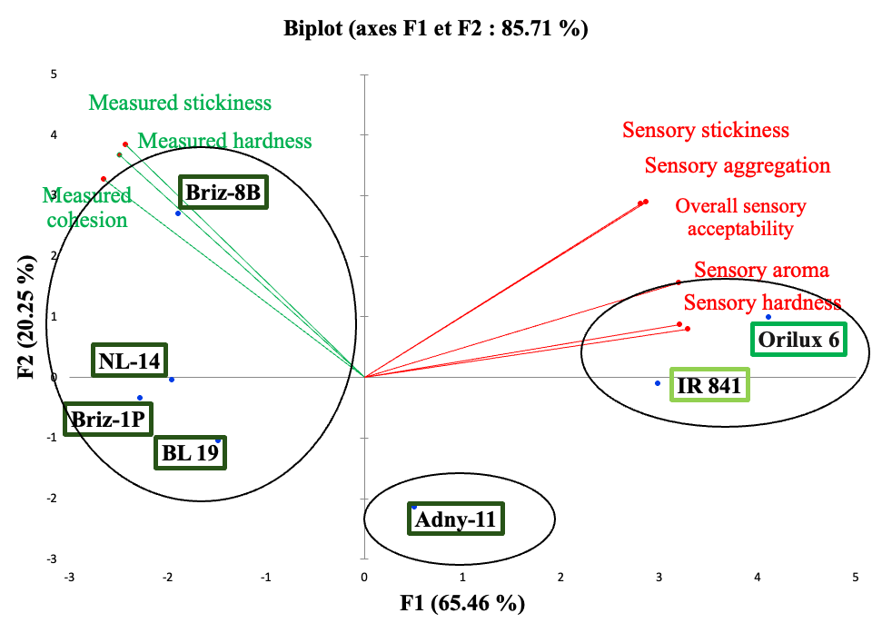
-
-
High amylose content
Intermediate amylose content
High amylose content
Instrumental Measured traits
Sensory traits

2

1

3

Figure 5. Two-dimensional projection of rice varieties and cooked rice quality traits
The two axes explained 87.40% of the information, with 64.97% for the F1 axis. There was a negative relationship between instrumental measured traits (hardness, cohesion, and stickiness) and sensory assessed traits (hardness, stickiness, grain aggregation, hardness). Therefore, consumers tend to dislike cooked rice when it gets harder, sticky and with high grain cohesion. Bao et al. (2023) found that such relations between traits are common in rice quality assessment and could be attributed to the inherent complexity of human sensory perception, which integrates multiple textural attributes simultaneously. This phenomenon was particularly evident for Orilux 6 and IR 841 varieties, which, received the highest sensory evaluations though exhibiting lower instrumental texture values. These results are also consistent with the findings of Mané et al. (2021) on the acceptability of cooked rice in West Africa. In the latter study, the acceptability of cooked rice was strongly influenced by its texture, with a clear preference for moderately hard rice.
From the spatial projection, three homogeneous groups of varieties were identified. Group 1 included Orilux 6 and IR 841 varieties, Group 2 contains Briz 8B, Briz 1P, NL 14, and BL 19, whereas Adny 11 represented Group 3. These first two groups had relatively opposite traits. Group 1 included varieties with low and intermediate amylose content, resulting in the lowest measured texture values and the highest cooked rice sensory scores. Group 2 varieties, characterised by their high amylose content, exhibited high measured texture values but low sensory scores for cooked rice. Properties of the variety from Group 3 appeared to be intermediate between those of Groups 1 and 2. The Adny11 variety has a high amylose content and yields high-cooked rice sensory scores, along with low measured texture values, that could have inserted it in group 1.
    - Amylose content effect on cooked rice sensory acceptability and instrumental traits
In Figure 6 were illustrated the results of a principal component analysis of the relationships among amylose content, textural measured traits, and sensory traits of cooked rice in an F1-F2 axis system.
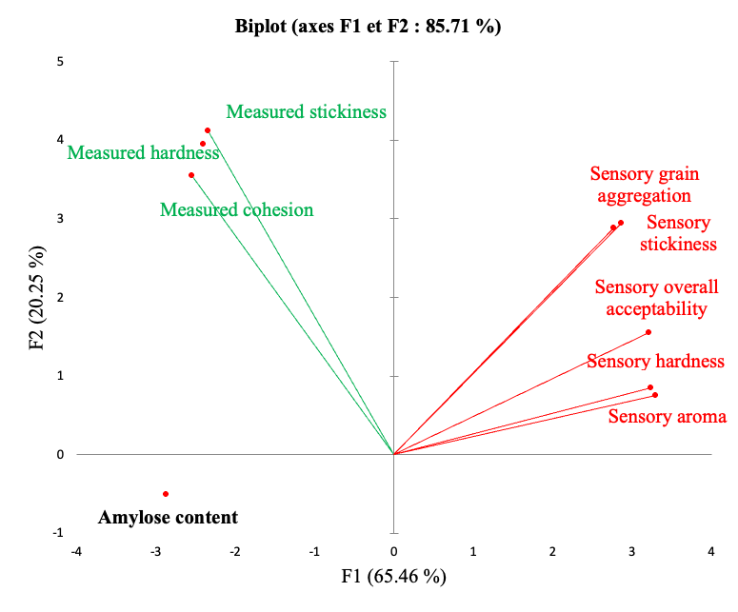
-
-
Measured traits
Sensory traits

Figure 6. Relationship between amylose content, sensory and instrumental traits for cooked rice
Cumulative eigenvalues indicated that the two axes (F1 and F2) together accounted for 85.71% of the information, with F1 explaining 65.46% of the data. Projecting the amylose content revealed a negative correlation with all sensory attributes, as noted, particularly the overall sensory acceptability score of cooked rice. It was observed that rice varieties with low (IR 841) and intermediate (Orilux 6) amylose content produced cooked rice that was less hard and sticky, generally preferred by West African consumers, as explained by the high acceptability of these varieties.
  - Ablo
    - Physicochemical traits of intermediate products of Ablo process and texture profile of Ablo
In Table 3 (a and b) were presented data on the viscoelastic properties (gel point and Tan α), the pH of fermented dough from different varieties, and the density and texture properties of the Ablo.
Table 3. Physicochemical traits of intermediate products of Ablo process and the texture profile of Ablo depending on amylose content
- Physicochemical traits of fermented and cooked dough obtained during Ablo production
Amylose content | Varieties | Fermented dough |  | Cooked dough
Amylose content | Varieties | Gel point (mPa.s) | Viscoelasticity Tan α (mPa.s) | pH
Low | IR841 | 4.16 ± 1.22^{c} | 0.54 ± 0.02ª | 4.71 ± 0.01ª
Intermediate | Orilux 6 | 5.71 ± 0.68^{c} | 0.61 ± 0.03ª | 4.65 ± 0.02^{ab}
High | Adny11 | 3.25 ± 0.78^{c} | 0.65 ± 0.09ª | 4.53 ± 0.16^{bc}
High | BL19 | 15.24 ± 1.57ª | 0.41 ± 0.03^{b} | 4.43 ± 0.01^{c}
High | Briz-1P | 6.63 ± 0.87^{b} | 0.55 ± 0.02ª | 4.65 ± 0.02^{ab}
High | Briz-8B | 3.71 ± 0.57^{c} | 0.57 ± 0.02ª | 4.65 ± 0.00^{ab}
High | Tulip (standard) | 5.66±0.35^{bc} | 0.59 ± 0.04ª | 4.39 ± 0.01^{c}
Within the same column means with the same letter are not significantly different (0.05%).
- Bulk density and textural properties of Ablo
Amylose  content | Varieties | Ablo
Amylose  content | Varieties | Bulk density  (g/ml) | Hardness (N) | Chewiness (N) | Stickiness N) | Resilience
Low | IR841 | 1.16 ± 0.17^{ab} | 42.60 ± 5.95^{d} | 10.75 ± 1.74e | 13.22 ± 1.8^{d} | 0.09 ± 0.01ª
Intermediate | Orilux 6 | 1.41 ± 0.20ª | 54.91 ± 3.68^{bc} | 17.29 ± 1.79^{cd} | 19.79 ± 1.6^{c} | 0.07 ± 0.02^{ab}
High | Adny11 | 1.06 ± 0.12^{ab} | 52.61 ± 13.19^{c} | 20.06 ± 5.93^{bc} | 23.15 ± 6.1^{b} | 0.05 ± 0.02^{bc}
High | BL19 | 0.93 ± 0.08^{b} | 88.96 ± 4.46ª | 36.59 ± 1.99ª | 41.41 ± 1.5ª | 0.00 ± 0.00^{d}
High | Briz-1P | 1.35 ± 0.50^{ab} | 44.91 ± 4.98^{d} | 15.61 ± 1.48^{d} | 17.60 ± 1.4^{c} | 0.04 ± 0.02^{bc}
High | Briz-8B | 1.08 ± 0.12^{ab} | 56.33 ± 3.64^{bc} | 21.68 ± 1.80^{b} | 24.39 ± 2.3^{b} | 0.03 ± 0.01^{c}
High | Tulip  (standard) | 0.98 ± 0.23^{b} | 59.04 ± 8.74^{b} | 20.89 ± 4.02^{b} | 24.99 ± 3.5^{b} | 0.08 ± 0.07ª
Within the same column means with the same letter are not significantly different (0.05%).
The highest gel point value was observed for the Adny-11 variety, at 15.24 ± 1.57 mPa.s, indicating a stronger dough structure (Karim et al., 2024). This variety also stood out for having the lowest Tanα value of 0.41 ± 0.03. Tanα < 1 observed in fermented dough from all varieties indicated a stable gel, essential for gas retention and the development of the porous structure of a bread-like product (Juszczak et al., 2012), such as Ablo. There was a very significant difference between the Adny-11 variety and the other varieties at 5% threshold. The pH values of the fermented dough ranged from 4.43 ± 0.01 to 4.71 ± 0.01 close to the value of Bokossa et al., (2013) of 4,28 ± 0,035. Moderate acidification not only preserves the product but also develops characteristic flavors. Ablo density varies from 0.93 ± 0.08 to 1.41 ± 0.20. The heaviest Ablo came from the Orilux 6 variety, while the lightest came from the Adny-11 variety. The lightest density of Ablo is a trait highly appreciated by consumers (Houngbédji et al., 2018). The extreme values for hardness, chewiness, stickiness, and resilience were 42.60±5.95 N to 88.96±4.46 N, 10.75±1.74 N to 36.59±1.99 N, 13.22±1.84 N to 41.41±1.53 N, and 0.00±0.00 to 0.09±0.01, respectively. BL19 variety produced the hardest, stickiest, and most flexible Ablo with the highest chewiness. However, the IR 841 variety produced the least hard and least sticky Ablo with low chewiness.
    - Sensory Profile of Ablo
In Figure 7 was presented the mean sensory scores (related to whiteness, hardness, lightness, and overall acceptability) for Ablo, obtained from different locally grown rice varieties, and the one obtained from the imported rice variety named Tulip, used as a standard. For each attribute, scores range from 0 to 7, with higher scores indicating greater consumer preference. Score 1 was very unpleasant, score 2 was unpleasant, score 3 was somewhat unpleasant, score 4 was neither pleasant nor unpleasant, score 5 was somewhat pleasant, score 6 was pleasant, score 7 was very pleasant. For the attribute of whiteness, all varieties had a score of 5 or higher, which is somewhat pleasing to consumers.

Overall acceptability
Overall acceptability

Figure 7. Sensory scores for Ablo obtained from locally grown vs. imported rice varieties
The varieties Briz 8B, BL-19, and Tulip obtained higher whiteness scores of 5.8, 5.8, and 5.5, respectively, compared with the other varieties. They were followed by the other varieties, which have a score close to 5, which are more elevated than those of Houngbedji et al. (2015) with the value of 0 Ablo from broken not polished IR841 variety. Considering lightness, the most appreciated Ablo was obtained with the variety Briz 8B, with the value of 5.4, followed by Tulip (5.3) and Adny-11 (5.0). Therefore, Briz 8B and Adny-11, locally grown rice varieties are as performant as the imported rice.
Regarding textural properties, hardness scores indicated a preference for Ablo obtained from Briz-8B (5.3) and Adny-11 (5.0). Tulip, IR 841, and Briz-1P were moderately appreciated with a mean score of 5, while BL-19 and Orilux 6 were less appreciated (4). Consumers' overall acceptability for Ablo revealed that the Adny-11 and Briz-8B rice varieties have sensory properties that make them 'pleasant'. Tulip, IR 841, followed them, and Briz-1P, which were somewhat peasants, and the other varieties were considered, 'neither pleasant nor unpleasant'. Sensory evaluation showed that the Ablo obtained from varieties Adny-11 and Briz-8B, was preferred by consumers over Tulip, the imported rice varieties generally used by producers. Therefore, it is possible to produce Ablo using these two locally grown for an Ablo which will be well accepted by consumers over imported rice. As previously noticed by Ezin (2022), consumers preferred white Ablo, with high lightness and intermediate hardness.
    - Relationship Between Instrumental Measured Traits and Sensory Acceptability of Ablo
In Figure 8 was shown the projection of the physicochemical properties of Ablo dough and instrumental textures and sensory acceptability of Ablo on two dimensions (F1 and F2) that gathered 75.57% of the primary data. F1 (46.74%) appeared to explain most of the physicochemical and textural parameters. Axis F2 (28.83%) was primarily related to pH, density, and Ablo’ sensory acceptability scores. Instrumental measured cohesion and sensory whiteness showed a strong positive correlation. Conversely, negative correlations were observed between Ablo density and the measured cohesion/sensory whiteness. Tan α exhibited an inverse relationship with the overall acceptability, sensory lightness, and sensory hardness, indicating that products with a heavier texture or lower elasticity tend to have higher tan α values. Three homogeneous groups were also identified. Varieties Orilux 6, IR841, and Briz 1P formed group 1; Briz 8B, Tulip, and Adny-11 formed group 2; and BL 19 formed group 3. BL-19 had a high amylose content and differed significantly formed groups 1 and 2 varieties, with the lowest sensory scores and the highest hardness, stickiness, chewiness, and Tanα values. The BL19 variety, which exhibited intermediate viscoelastic properties, produced the firmest and stickiest Ablo. This phenomenon can be explained by the complex interactions between amylose and amylopectin during cooking, which influence the final structure of the product (Chen et al., 2024). Group 2 varieties were characterized by high amylose content, which was associated with elevated sensory scores and the lowest physicochemical traits. This group was characterized by high overall acceptability, good hardness, and an appealing light texture. Varieties within this group had a high overall acceptability rate (65%), which can be attributed to an optimal balance between the dough's viscoelastic properties and the final product's textural characteristics. Group 1 comprises varieties that were not characterized by their amylose content. It contains varieties with low, intermediate, and high amylose content with no correlation with sensory attributes, high density, and low textural properties, and had moderate acceptability scores.
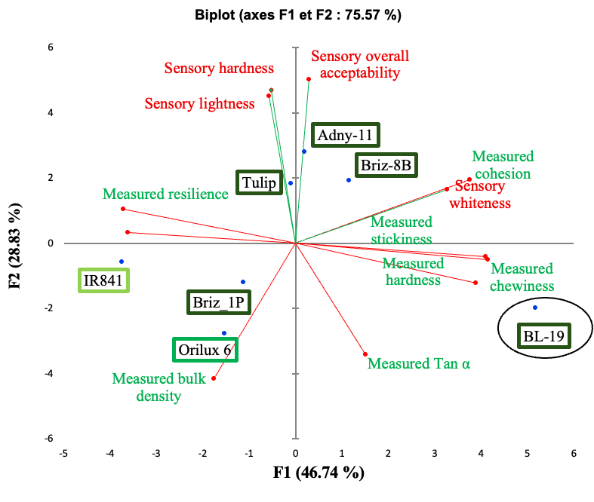
-
-
Intermediate amylose content
High amylose content
Instrumental measured traits
Sensory traits
High amylose content
1
2
3

Figure 8. Two-dimensional projection of rice varieties and traits of rice-based Ablo
    - Effect of Amylose Content on Instrumental measured traits and Sensory Acceptability of Ablo
In Figure 9 was shown the principal component analysis, which allowed to visualize the distributions of sensory traits, measured traits, and amylose content for the different rice varieties along F1 and F2 axes. The cumulative eigenvalues indicated that the two axes (F1 and F2) collectively account for 80.57% of the total variance, with F1 accounting for 47.52%. Sensory attributes (overall acceptability, hardness, and lightness) were negatively correlated with instrumental measured texture characteristics of Ablo on the F1 axis. The amylose content exhibited a positive relationship with textural characteristics, such as hardness, chewiness, and stickiness, but not a correlation with sensory attributes. This suggests that a high amylose content of rice was not necessarily associated with a higher sensory acceptability of the derived Ablo.
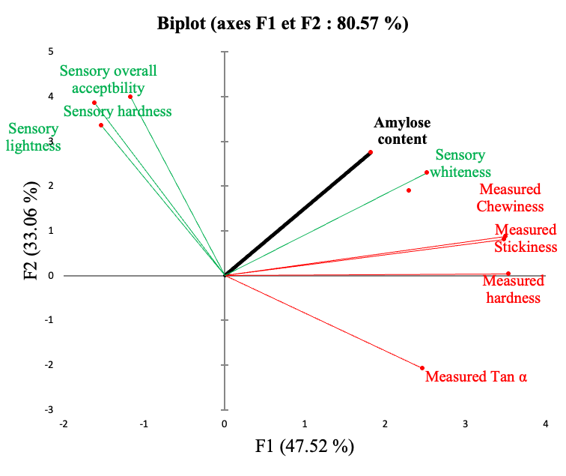
-
-
Measured traits
Sensory traits

Figure 9. Relationship between amylose content and sensory and measured traits for Ablo
  - Predicting sensory acceptability of cooked rice based on its physicochemical traits
Analysis of the confusion matrices, presented in Figure 10 and used to predict cooked rice sensory attributes, revealed that model accuracy varied depending on the physicochemical traits used. The central scores (particularly levels 5 and 6) were generally more accurately predicted, while extreme scores were more difficult to predict. Performance was acceptable for the most frequent scores of whiteness and grain aggregations, but poor for intermediate or rare shades. For aroma and hardness, consistency was good for scores 5 and 6, although confusion arose between neighbouring scores, reflecting difficulty in distinguishing between similar olfactory or textural levels. The stickiness attribute demonstrated moderate accuracy, with reliable prediction of score 6, but frequent errors between scores 5 and 6. Finally, in the overall assessment, scores 5 and 6 are most consistently recognized, despite persistent confusion between adjacent levels. Overall, the model achieved satisfactory accuracy for central scores but needs improvement to better discriminate between neighbouring and extreme scores. The performance attributes in Table 4 showed a low ability of the physicochemical traits model to correctly predict the scores of the different sensory attributes of cooked rice. Indeed, the mean sensitivity score was generally low across all attributes, ranging from 0.1532 for hardness to 0.2827 for stickiness.
This indicates difficulty in correctly detecting true positives, resulting in a high classification error rate. Conversely, the mean score specificity, which reflects the model’s ability to correctly identify negative observations, was relatively high for all attributes, exceeding 0.86 in every case, with a maximum of 0.8979 for grain aggregation and aroma. This suggests that although the model struggles to correctly identify certain scores, it performs better at excluding false classifications. Overall precision remains relatively low, ranging from 0.3158 for hardness to 0.4444 for stickiness, suggesting insufficient overall predictive accuracy. The best-performing attributes, such as stickiness (0.44) and overall acceptability (0.41), remain below the 50% threshold, meaning that the model’s predictions were only slightly better than random choice. These results therefore suggest that the sensory characteristics of cooked rice may be influenced by other parameters beyond the physicochemical attributes considered in this study.
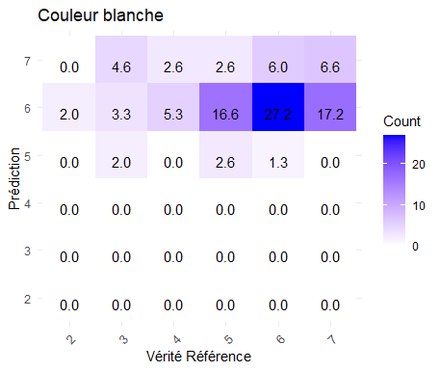
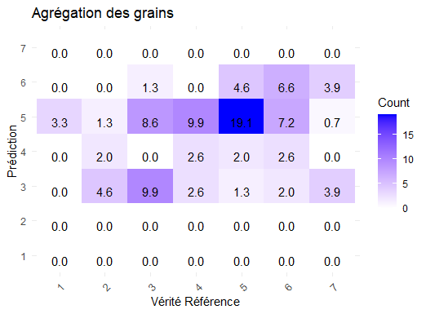
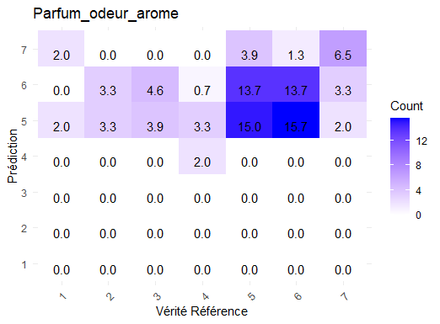
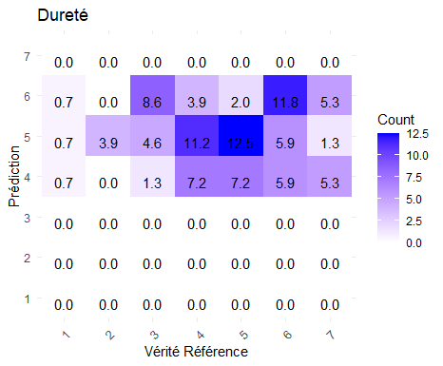
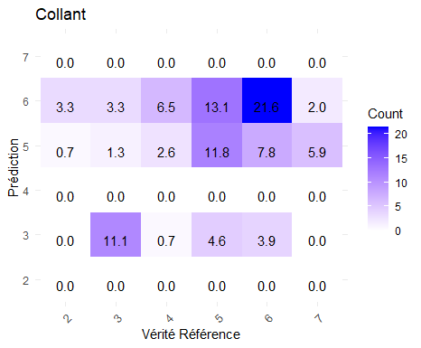
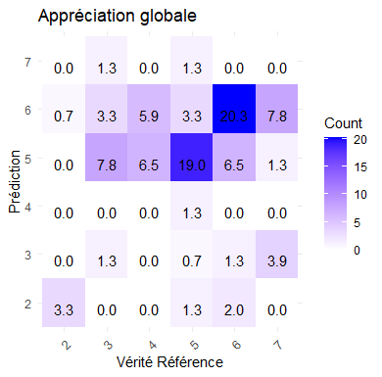
Whiteness
Grain agregation
Aroma
Hardness
Stickiness
Overall acceptability

Figure 10. Confusion matrix of predicted sensory attributes for cooked rice
Table 4. Prediction performance of sensory attributes for cooked rice
Cooked rice sensory attributes | Predictive performance
Cooked rice sensory attributes | Mean score sensitivity | Mean score specificity | Accuracy
Whiteness | 0.2638 | 0.8675 | 0.3642
Grain aggregation | 0.2798 | 0.8979 | 0.3816
Aroma | 0.2798 | 0.8979 | 0.3725
Hardness | 0.1532 | 0.8600 | 0.3158
Stickiness | 0.2827 | 0.8673 | 0.4444
Overall acceptability | 0.2504 | 0.8741 | 0.4118
  - Predicting Sensory Acceptability of Ablo Based on its Physicochemical Traits
The confusion matrices in Figure 11 evaluated the ability of Ablo's physical parameters to correctly predict its sensory attributes. Each matrix highlighted the distribution of predictions relative to actual values, allowing the identification of true positives (correct predictions) and false negatives (misclassifications). The objective was to assess the extent to which physicochemical parameters explain sensory attributes. In terms of whiteness, true positives were well represented, particularly for scores 2 (12.58%), 4 (7.94%), 5 (12.58%), 6 (37.08%), and 7 (11.26%). However, misclassifications occur, especially for score 4, where 4.6% of samples were classified as score 6, and 5.29% of score 5 were predicted as score 7. This suggests that the physicochemical parameters captured some nuances of whiteness but struggled to accurately distinguish among them and to close the scores. For hardness, the matrix showed good predictions for scores 2 (8.55%), 4 (6.58%), 5 (5.26%), 6 (23.68%), and especially 7 (46.71%), indicating that the selected physicochemical parameters effectively explain this indicator.
However, score 5 showed confusion with scores 2 (3.95%), 6 (2.63%), and 5 (2.63%), highlighting limitations in distinguishing medium hardness levels. Regarding lightness, predictions were generally accurate for scores 2 (8.6%), 4 (6.58%), 5 (3.94%), 6 (40.13%), and 7 (28.29%). Nevertheless, score 3 illustrated no correct classification and some confusion, indicating that the physical parameters used are insufficient to characterize this specific attribute. Finally, for overall acceptability, the matrix presented very accurate predictions for score 7 (54.9%), as well as good results for scores 2 (12.4%), 5 (11.11%), and 6 (13.7%). However, score 3 showed confusion with score 7 (3.9%), reflecting difficulty in distinguishing intermediate acceptability levels. Overall, these results demonstrated that physicochemical parameters provide good predictive power for sensory attributes, although some specific scores remain more challenging to discriminate. The calculated performance indicated in Table 5 enables assessment of the reliability of predictions for Ablo's sensory attributes.
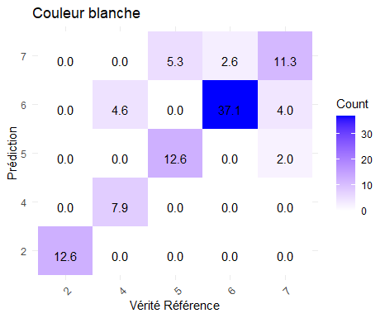
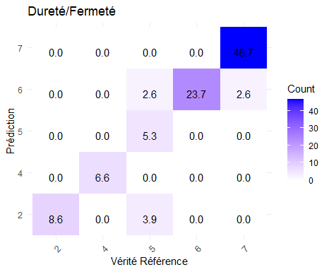
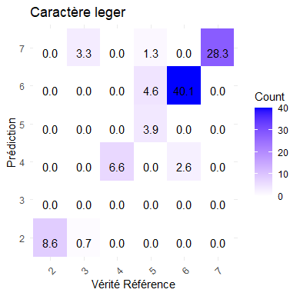
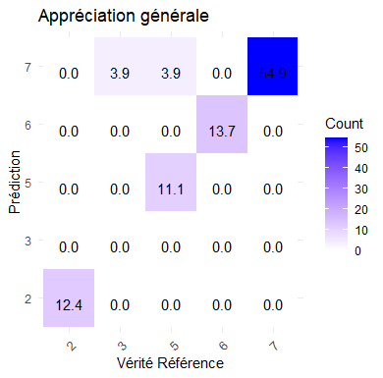
Whiteness
Hardness

Lightness

Overall acceptability

Figure 11. Confusion matrix of predicted sensory attributes for Ablo
Table 5. Performance of sensory attributes for Ablo prediction
Ablo sensory attributes | Predictive performance
Ablo sensory attributes | Mean score sensitivity | Mean score specificity | Accuracy
Whiteness | 0.6040 | 0.7809 | 0.7959
Hardness | 0.6740 | 0.8000 | 0.8947
Lightness | 0.7080 | 0.9740 | 0.8684
Overall acceptability | 0.6190 | 0.8080 | 0.9216
The mean score sensitivity, which measures the model’s ability to correctly identify each score, ranges from 0.604 for whiteness to 0.708 for lightness, indicating better detection of lightness. Hardness and overall acceptability showed sensitivities of 0.674 and 0.619, respectively, suggesting that these attributes are also well captured, though with a slightly higher margin of error for overall acceptability. This means that some scores were occasionally misidentified, consistent with the confusion matrix results, particularly for intermediate scores. Conversely, the mean specificity score, which reflects the model’s ability to avoid false classifications, was generally high, ranging from 0.7809 for whiteness to 0.974 for lightness, indicating very good precision in identifying lightness. Hardness and overall acceptability display specificities of 0.80 and 0.808, respectively, highlighting strong discriminative ability. The overall accuracy, which measured the total proportion of correct predictions, was particularly high, 0.9216 for overall acceptability and 0.8947 for hardness/hardness, demonstrating excellent model performance for these attributes. Even for whiteness, which presented the lowest sensitivity, accuracy remains high at 0.7959, indicating that despite some classification errors, the predictions were overall reliable and robust.

  - How in Benin, rice variety and amylose content significantly dictate the texture and sensory acceptability of local dishes?
The link between rice variety amylose content, texture, and the sensory acceptability of dishes varies by region. In Asia, especially in China, but also in the United States of America, rice variety and amylose content significantly dictate the texture and sensory acceptability of local dishes. High-amylose rice (Indica type) results in firmer, less sticky, and often preferred cooked rice, while low-to-intermediate amylose rice yields softer, stickier textures that are less desirable for traditional, non-sticky rice consumption (Yu et al., 2009; Farooq and Yu 2025; Zhao et al., 2025). The opposite was observed in Bénin. Regarding rice grown in the region, the following are mentioned:
- Rice Amylose content and Product Texture Relationship: A positive correlation was observed between rice amylose content and dishes textural properties. Cooked rice and Ablo obtained from high amylose content (>25%) rice (as defined Juliano (1992)) correlates with high hardness and low stickiness of the end products. Conversely, low (10–20%) and Intermediate (20–25%) amylose content rice varieties produce softer, stickier, or more adhesive end products.
- Sensory Acceptability in Bénin: Cooked rice consumers often prefer rice varieties with low-to-intermediate amylose content, as they produce a soft and non-sticky texture in cooked rice. However, Ablo consumers prefer rice varieties with high amylose content, which make a soft Ablo in comparison with rice varieties holding high amylose content and hard Ablo, such as BL-19. Beyond amylose content, other rice variety parameters determine its sensory acceptability. Whether for Ablo and cooked rice, Beninese consumers prefer soft texture.
- Variety Performance: Varieties such as Briz 8B and Adny-11 often exhibit high amylose content, which is desirable for Ablo production. Locally grown rice varieties and improved lines (like Orilux 6 and IR 841) are tested for their eating qualities, with preference often given to those with good aroma and cooking abilities, which often correlate with low to intermediate amylose.
- Processing Factors: The use of parboiled rice flour during the process of Ablo production is not yet common in Benin. It has been recently tested and validated by Ezin (2022). The use of parboiled rice flour does not affect the amylose content; however, the starch structure changes, which can reduce cooking time and modify the final product properties. Microstructure analyses reported in the literature further confirm that parboiled rice exhibits a denser, more homogeneous internal structure compared with native rice, thereby limiting the generation of fines and favouring coarser particles (Iqbal et al., 2021). The use of this processed rice further reduces the firmness and increases the lightness of the final product.
The consequences of such findings for rice-based foods could be mentioned as follows:
- for white rice grain: Low- and intermediate-amylose varieties are preferred for their softness and separate-grain texture in Benin;
- for rice-based flours/pastes: Varieties with high amylose are better suited for dough-based dishes such as Ablo.
- Conclusion and Perspectives
The study elucidates the complex relationships between the amylose content of rice varieties and their performance in different food applications in Benin. The multidimensional approach, combining physicochemical, rheological, and sensory analyses, shows that the impact of amylose on the final product properties varies. The study demonstrates that low-amylose (IR 841) and intermediate amylose (Orilux 6) varieties are preferable for cooked rice, whereas certain high-amylose varieties (Adny-11, Briz-8B) are suitable for Ablo production, provided they possess favourable starch structural characteristics. Thus, the study provides objective selection criteria to optimize the use of rice varieties in different culinary applications in Benin. The results indicate that low- to intermediate-amylose rice varieties are more appropriate for cooked rice. Ablo quality is not directly correlated with amylose content; however, some high-amylose varieties still yield high-quality Ablo due to favourable structural properties. The predictive models developed demonstrate greater reliability for Ablo than for cooked rice, suggesting more complex processing mechanisms in the latter case. Future research should systematically measure additional physicochemical and rheological parameters not assessed in the present study, which currently limit the ability to explain or link the phenomena observed in cooked rice. Integrating these measurements improves the understanding of the interactions between rice composition and final quality, thereby contributing to the improvement of Beninese rice production.
- Acknowledgments
The authors are thankful to the French Development Agency for the “Strengthening skills development and entrepreneurial culture in higher agricultural education: levers for professional integration and the development of bioeconomy in Benin” project, entitled PEA-BIOVALOR, which supported this work. They expressed their gratitude to Roland EZIN, to the various interns and technicians from the Laboratory of Food Science and Technology (LaSTA) from Université d’Abomey-Calavi, of “Laboratoire d’Ingénierie des Biomolécules” (LiBIo) from Université de Nancy, and those of the “Centre de Coopération Internationale en Recherche Agronomique pour le Développement” (CIRAD) for their contribution to this study.
- Conflicts of Interest
The authors declare no conflict of interest. The funders had no role in the design of the study; in the collection, analyses, or interpretation of data; in the writing of the manuscript; or in the decision to publish the results.
- Authors Contributions
All authors have read and agreed to the published version of the manuscript. Therefore, here are the following specific contributions: -i- Conceptualization by M. Daouda and Y. E. Madode; -ii- Methodology by M. Daouda and M. Oussou; -iii- Software by M. Oussou and M. Daouda; -iv- Validation by J. Jasniewski and Y. E. Madode; -v- Formal analysis by M. Oussou and M. Daouda; -vi- Investigation by M. Oussou and M. Daouda; -vii- Resources by PEA-BIOVALOR; -viii- Data curation by J. Jasniewski and Y. E. Madode; -ix- Writing original draft preparation by M. Daouda and M. Oussou; -x- Writing reviews and editing by M. Oussou and M. Daouda; -xi- Visualization by M. Daouda and Y. E. Madode; -xii- Supervision by J. Jasniewski and Y. E. Madode; -xiii- Project administration by J. Jasniewski and Y. E. Madode; -xiv- Funding acquisition by Y. E. Madode.
- References
Adinsi, L., N. H. Akissoé, G. Dalodé‐Vieira, V. B. Anihouvi, G. Fliedel, C. Mestres, J. D. Hounhouigan, 2015: Sensory Evaluation and Consumer Acceptability of a Beverage Made from Malted and Fermented Cereal: Case of Gowe from Benin. Food Science & Nutrition 3 (1): 1–9. https://doi.org/10.1002/fsn3.166.
Bao, J., B. Deng, L. Zhang. 2023: Molecular and Genetic Bases of Rice Cooking and Eating Quality: An Updated Review. Cereal Chemistry 100 (6): 1220–33. https://doi.org/10.1002/cche.10715.
Bokossa, I. Y., J. Banon, C. C. K. Tchekessi, P. Dossou-Yovo, K. Adeoti, E. Assogba. 2013: Caractérisation Physico-Chimique et Microbiologique de Ablo : Une Pâte Fermentée Du Bénin. 15 (2): 389–97. https://www.researchgate.net/publication/293827958_CARACTERISATION_PHYSICO-CHIMIQUE_ET_MICROBIOLOGIQUE_DE_ABLO_UNE_PATE_FERMENTEE_DU_BENIN.
Chen, Z., A. Hu, A. Ihsan, J. Zheng. 2024: The Formation, Structure, and Physicochemical Characteristics of Starch-Lipid Complexes and the Impact of Ultrasound on Their Properties: A Review. Trends in Food Science & Technology 148 (June): 104515. https://doi.org/10.1016/j.tifs.2024.104515.
Dansou, V., P. A. F. Houssou, Y. S. R. Kouke, A. B. Hotegni, W. A. C. Sagui, K. Aboudou, H. Zannou, 2023: Physicochemical and sensory characterization of five promising aromatic rice accessions in Benin. Food and Environment Safety Journal 22 (1). https://doi.org/10.4316/fens.2023.004.
Ezin, R. 2022: Formulation d’une farine prête à fermenter pour la production d’un Ablo de riz accepté des consommateurs du produit traditionnel. Master degree. Université d’Abomey-Calavi, September.
Farooq, M. A., J. Yu. 2025: Starches in Rice: Effects of Rice Variety and Processing/Cooking Methods on Their Glycemic Index. Foods 14 (12): 2022. https://doi.org/10.3390/foods14122022.
Fofana, M., K. Futakuchi, J.T. Manful, I. B. Yaou, J. Dossou, R.T.M. Bleoussi. 2011: Rice Grain Quality: A Comparison of Imported Varieties, Local Varieties with New Varieties Adopted in Benin. Food Control 22 (12): 1821–25. https://doi.org/10.1016/j.foodcont.2011.04.016.
Gnacadja, C., P. Azokpota, J. Moreira, M. Sie. 2018: Perceptions des producteurs et consommateurs sur le riz africain (Oryza glaberrima). International Journal of Biological and Chemical Sciences 11 (6): 2778. https://doi.org/10.4314/ijbcs.v11i6.18.
Hebishy, E., D. Buchanan, J. Rice, S. A. Oyeyinka. 2024: Variation in Amylose Content in Three Rice Variants Predominantly Influences the Properties of Sushi Rice. Journal of Food Measurement and Characterization 18 (6): 4545–57. https://doi.org/10.1007/s11694-024-02513-x.
Houngbedji, M., D. J. Hounhouigan, N. Akissoe, C. Mestres. 2015: Valorisation du riz local: optimisation du procédé traditionnel de production de Ablo à base de brisures de riz. Université d’Abomey-Calavi.
Houngbédji, M., Y. E. Madodé, C. Mestres, N. Akissoé, J. Manful, B. Matignon, J. Grabulos, D. J. Hounhouigan, 2018: The Quality of Steam-Cooked Rice Bread Is Directly Linked with the Level of Starch Gelatinization and the Fluidity of Fermented Dough. Journal of Cereal Science 80 (03): 1–8. https://doi.org/10.1016/j.jcs.2018.01.006.
Houssou, P. A. F., V. Dansou, A. B. Hotegni, K. Aboudou, H. Zannou, R. Y. S. Kouke. 2024: Assessement of the qualities of new aromatic rice accessions stored at farmers level in Benin. Scientific Study & Research. Chemistry & Chemical Engineering, Biotechnology, Food Industry 25 (January): 049–060. https://www.proquest.com/scholarly-journals/assessment-qualities-new-aromatic-rice-accessions/docview/3032755454/se-2.
Iqbal, S., P. Zhang, P. Wu, A. Ge, F. Ge, R. Deng, X. D. Chen, 2021: Evolutions of Rheology, Microstructure and Digestibility of Parboiled Rice during Simulated Semi-Dynamic Gastrointestinal Digestion. LWT 148 (08): 111700. https://doi.org/10.1016/j.lwt.2021.111700.
Juliano, B. O. 1992. Structure, Chemistry, and Function of the Rice Grain and Its Fractions. 37 (10): 772–79. https://www.researchgate.net/publication/285022942_Structure_chemistry_and_function_of_the_rice_grain_and_its_fractions.
Juszczak, L., T. Witczak, R. Ziobro, J. Korus, E. Cieślik, M. Witczak. 2012: Effect of Inulin on Rheological and Thermal Properties of Gluten-Free Dough. Carbohydrate Polymers 90 (1): 353–60. https://doi.org/10.1016/j.carbpol.2012.04.071.
Karim, Md D., Md Abuhena, Md D. Hossain, Md M. Billah. 2024: Assessment and Comparison of Cooking Qualities and Physio-Chemical Properties of Seven Rice Varieties in Terms of Amylose Content. Food Physics 1 (9): 100014. https://doi.org/10.1016/j.foodp.2024.100014.
MAEP (Ministère de l’Agriculture, de l’Élevage et de la Pêche). 2016. Catalogue Béninois Des Espèces et Variétés Végétales (CaBEV). INRAB/DPVPPAAO/ProCAD/MAEP&CORAF/WAAPP. Bibliothèque Nationale (BN) Du Bénin, 4ème Trimestre.
Mané, I., J. Bassama, M. Ndong, C. Mestres, P. M. Diedhiou, G. Fliedel. 2021: Deciphering Urban Consumer Requirements for Rice Quality Gives Insights for Driving the Future Acceptability of Local Rice in Africa: Case Study in the City of Saint‐Louis in Senegal. Food Science & Nutrition 9 (3): 1614–24. https://doi.org/10.1002/fsn3.2136.
Odenigbo, A. M., M. Ngadi, C. Ejebe, N. Woin, S. A. Ndindeng. 2014: Physicochemical, Cooking Characteristics and Textural Properties of TOX 3145 Milled Rice. Journal of Food Research 3 (2): 82. https://doi.org/10.5539/jfr.v3n2p82.
Sanusi, M.S., N. Danbaba, J. B. Hussein. 2022: Comparative Studies of the Effect of Processing Conditions on Cooking and Sensory Properties of Selected Rice Varieties. African Journal of Food, Agriculture, Nutrition and Development 22 (115): 21785–806. https://doi.org/10.18697/ajfand.115.20855.
Tomlins, K.I., J.T. Manful, P. Larwer, L. Hammond. 2005: Urban Consumer Preferences and Sensory Evaluation of Locally Produced and Imported Rice in West Africa. Food Quality and Preference 16 (1): 79–89. https://doi.org/10.1016/j.foodqual.2004.02.002.
Yu, S., Y. Ma, D-W. Sun. 2009: Impact of Amylose Content on Starch Retrogradation and Texture of Cooked Milled Rice during Storage. Journal of Cereal Science 50 (2): 139–44. https://doi.org/10.1016/j.jcs.2009.04.003.
Zhao, D., Y. Deng, Q. Huang, G. Liu, Y. Zhang, X. Tang, P. Zhou, Z. Zhao, J. Zeng, Y. Liu, 2025: Influence of Rice Physicochemical Properties on High-Quality Fresh Wet Rice Noodles: Amylose and Gel Consistency as Key Factors. Gels 11 (9): 696. https://doi.org/10.3390/gels11090696.

